**Final Year Project Document**

**Version 1.2**

**Student Support and Navigation App - SSNA**

**FYP Team**

**Muhammad Ashar Zafar 20F - 0240**

**Muhammad Ehsan Akhtar 20F - 0312**

**Muhammad Shahzaib Shafiq 20F - 0317**

**Supervised by:**

**Mr. Tahir Farooq**

**Co - supervised by:**

**Ms. Areeba Waseem**

**Department of Computer Science**

**National University of Computer and Emerging Sciences**

**Chiniot - Faisalabad Campus, Pakistan.**

**2023**

Table of contents

**1.** **Introduction** 1

**2.** **Vision Document** 1

**2.1.** **Problem Statement** 1

**2.2.** **Business Opportunity** 1

***2.2.1.*** ***Licensing to Universities*** 1

***2.2.2.*** ***In-App Advertising:*** 2

***2.2.3.*** ***Career Services Integration:*** 2

***2.2.4.*** ***Data Analytics for Universities:*** 2

***2.2.5.*** ***Security and Privacy Services:*** 2

**2.3.** **Objectives** 2

**2.4.** **Scope** 2

**2.5.** **Constraints** 3

**2.5.1.** ***Technical Constraints****:* 3

**2.5.2.** ***Data Privacy and Security****:* 3

**2.5.3.** ***Integration Challenges****:* 3

**2.5.4.** ***User Adoption****:* 3

**2.5.5.** ***Scalability****:* 3

**2.5.6.** ***Limited Mobile Device Capabilities****:* 4

**2.5.7.** ***Testing and Quality Assurance****:* 4

**2.6.** **Stakeholder and User Description** 4

2.6.1 ***Market Demographics:*** 4

***2.6.2*** ***Stakeholder Summary:*** 4

***2.6.3*** ***User Environment:*** 4

***2.6.4*** ***Stakeholder Profiles*** 5

**3.** **System Requirement Specifications** 5

**3.1.** **System Features** 5

***3.1.1.*** ***User Authentication and Profiles:*** 5

***3.1.2.*** ***Academic Resources****:* 5

***3.1.3.*** ***Communication Tools****:* 6

***3.1.4.*** ***Event Listings****:* 6

***3.1.5.*** ***Campus Map****:* 6

***3.1.6.*** ***News and Updates****:* 6

***3.1.7.*** ***User Directory****:* 6

***3.1.8.*** ***User Engagement and Social Features****:* 6

***3.1.9.*** ***Notifications and Alerts****:* 6

***3.1.10.*** ***Security and Privacy****:* 6

***3.1.11.*** ***Customization and Branding (optional)****:* 7

***3.1.12.*** ***Help and Support****:* 7

**3.2.** **Functional Requirements** 7

***3.2.1.*** ***User Authentication****:* 7

***3.2.2.*** ***User Profiles****:* 7

***3.2.3.*** ***Academic Resources****:* 7

***3.2.4.*** ***Communication Tools****:* 7

***3.2.5.*** ***Event Management****:* 8

***3.2.6.*** ***Campus Map****:* 8

***3.2.7.*** ***News and Updates****:* 8

***3.2.8.*** ***User Directory****:* 8

***3.2.9.*** ***User Engagement and Social Features****:* 8

***3.2.10.*** ***Virtual Campus Tours****:* 8

***3.2.11.*** ***Security and Privacy****:* 8

***3.2.12.*** ***Customization and Branding****:* 8

**3.3.** **Non-Functional Requirements** 9

***3.3.1.*** ***Performance****:* 9

***3.3.2.*** ***Security****:* 9

***3.3.3.*** ***Reliability****:* 9

***3.3.4.*** ***Usability and Accessibility****:* 10

***3.3.5.*** ***Compatibility****:* 10

***3.3.6.*** ***Data Privacy and Compliance****:* 10

***3.3.7.*** ***Performance Monitoring****:* 10

***3.3.8.*** ***Network and Connectivity****:* 10

***3.3.9.*** ***Load Testing****:* 10

***3.3.10.*** ***Compliance with Standards****:* 11

***3.3.11.*** ***User Support and Documentation****:* 11

***3.3.12.*** ***Maintenance and Updates:*** 11

***3.3.13.*** ***Legal and Compliance****:* 11

List of tables

**3.4.** **Use Cases** 12

***3.4.1.*** Fully Dressed 12

**3.4.2.1** Table 1: Manage Course Material 12

**3.4.2.2** Table 2: Manage Announcements 12

**3.4.2.3** Table 3.: Manage Guidance Portal 13

**3.4.2.4** Table 4: Manage Events 13

**3.4.2.5** Table 5: Manage Timetable 13

**3.4.2.6** Table 6: Manage Faculty Info 14

**3.4.2.7** Table 7: Manage Buses 14

**3.4.2.8** Table 8: Manage users 15

**3.4.2.9** Table 9:Access guidance portal 15

***3.4.2.*** Brief Use Cases 16

**3.4.2.1** Table 1: Registration/Login 16

3.4.2.2 Table 2: Authentication 16

**3.4.2.3** Table 3: Browse course material 16

**3.4.2.4** Table 4: View Announcements 16

**3.4.2.5** Table 5: View events 16

**3.4.2.6** Table 6: View Timetable 17

**3.4.2.7** Table 7: Enable reminders. 17

**3.4.2.8** Table 8: Access faculty information 17

**3.4.2.9** Table 9: Manage Profile 17

**3.4.2.10** Table 10: Get Location 17

**3.4.2.11** Table 11: Approve requests 18

**3.4.2.10** Table 12:Search bus routes 18

**3.4.2.11** Table13:Download material 18

**3.4.2.12** Table 14: Post query 18

List of figures

**4.** **Diagrams** 19

**4.1.** **Use Case Diagram** 19

Figure 1. Use Case Diagram 19

**4.2.** **Activity Diagram** 20

Figure 2. Activity Diagram 1 20

Figure 3. Activity Diagram 2 21

Figure 4. Activity Diagram 3 22

Figure 5. Activity Diagram 4 23

Figure 6. Activity Diagram 5 24

Figure 7. Activity Diagram 6 25

Figure 8. Activity Diagram 7 26

**4.3.** **System Sequence Diagram** 27

Figure 9. System Sequence Diagram (SSD) 1 27

Figure 10. System Sequence Diagram (SSD) 2 28

Figure 11. System Sequence Diagram (SSD) 3 29

Figure 12. System Sequence Diagram (SSD) 4 30

Figure 13. System Sequence Diagram (SSD) 5 31

Figure 14. System Sequence Diagram (SSD) 6 32

**4.4.** **Component Diagram** 36

Figure 15. Component Diagram 36

**4.5.** **Data Flow Diagram** 37

Figure 16. Data Flow Diagram 1 37

Figure 17. Data Flow Diagram 2 38

Figure 18. Data Flow Diagram 3 39

**4.6.** **Database Schema** 40

Figure 19. Database Schema 1 40

# **Introduction**

In an era defined by digital innovation and connectivity, educational institutions are constantly seeking ways to enhance the student experience both inside and outside the classroom. Recognizing the evolving needs of modern-day students, we embark on an ambitious project to create an all-encompassing mobile application tailored specifically for university communities. This project aims to revolutionize campus life by providing students with a powerful tool that not only streamlines their academic journey but also fosters engagement, communication, and convenience. Our comprehensive university mobile app project encompasses a wide range of features and functionalities, all designed to empower students with the tools they need to succeed in their academic pursuits and thrive in the campus environment.

# **Vision Document**

## **Problem Statement**

The problem in the current system is that there is no central system to assist a student using a single platform. Our app will assist the new batch students as they face a lot of challenges in navigating through their timetable, finding their classrooms, and interacting with seniors for assistance. There is a need for a central system that can handle all these things in one application.

## **Business Opportunity**

Creating a comprehensive university mobile app opens various business opportunities that can benefit both educational institutions and students. Here are some potential business opportunities that can be implemented in our app:

* + 1. ***Licensing to Universities:*** Offer universities a licensing model where they can customize and brand the app for their institution. Charge universities based on the number of users or features they want to include.
    2. ***In-App Advertising:*** Partner with local businesses, bookstores, and restaurants to display targeted advertisements within the app. This can provide a revenue stream while also offering students exclusive discounts and deals.
    3. ***Career Services Integration:*** Collaborate with career services office to offer job listings and internship opportunities. Charge employers to post job openings and promote their brand within the app.
    4. ***Data Analytics for Universities:*** Offer universities data analytics services to help them understand student data and improve their overall services. Charge a fee for access to these analytics tools.
    5. ***Security and Privacy Services:*** Ensure the app complies with privacy regulations and offers robust security features. Charge universities for premium security and privacy services.

## **Objectives**

* New batch students face challenges in understanding their timetables.
* Provide PDFs and other relevant course material (slides, books).
* Interaction with seniors for guidance is essential but lacks a straight-forward approach.
* Campus Map, especially for newcomers, requires an easy-to-use map.
* Timetable management is crucial for effective time utilization.
* Contact information for various departments should be readily available.

## **Scope**

This project involves the development of a mobile application designed specifically for university communities, with the primary goal of simplifying the lives of students and improving their overall campus experience. The app will offer a complete set of features, including easy access to academic resources such as course schedules, syllabus, and digital textbooks, as well as an academic calendar to keep students updated on important dates. It will also provide communication tools for students to connect with their seniors, university-wide announcements to keep everyone informed, and a user-friendly interface for browsing campus events and activities. Additionally, the app will include a campus map for effortless navigation, a news feed for staying up to date with university happenings, and a portal for accessing various student support services, all accessible by students and guests. This initiative aims to create a user-friendly and engaging platform that enhances the overall campus experience for the entire university community.

## **Constraints**

While developing the university mobile app, we may encounter several constraints that could impact the project. These constraints may include:

1. ***Technical Constraints****:* Compatibility issues with various mobile devices and operating systems may arise, requiring additional development effort and testing to ensure a seamless user experience.
2. ***Data Privacy and Security****:* Strict data privacy regulations, such as the PDP bill in Pakistan, may impose constraints on data handling and storage, demanding strong security measures and compliance efforts.
3. ***Integration Challenges****:* Integration with our existing university systems, such as student information systems (SIS) may be complex and require cooperation from various departments.
4. ***User Adoption****:* Encouraging students to adopt and regularly use the app may be challenging, requiring a comprehensive marketing, and onboarding strategy.
5. ***Scalability****:* The app must be designed to accommodate potential increases in user numbers as the university community grows, which could impact infrastructure requirements and performance.
6. ***Limited Mobile Device Capabilities****:* Some users may have older or less capable mobile devices, which could limit the app's ability to host advanced features.
7. ***Testing and Quality Assurance****:* Intense testing across a wide range of devices and operating systems is essential, but requires time, this can extend the project timeline.

## **Stakeholder and User Description**

### ***Market Demographics:***

The market demographics for the university mobile app primarily target educational institutions, with a focus on universities. This market segment includes public and private universities. Spanning various geographic locations. The app's primary user demographic comprises students of these institutions. Additionally, potential guests visiting the campuses also form part of the user base. The app aims to address the needs of diverse academic disciplines and student populations, encompassing undergraduate, graduate, and professional programs.

### ***Stakeholder Summary:***

Stakeholders play a crucial role in such projects. These stake holders include university administrators responsible for overseeing campus technology and services who will interact with the application and utilize its features, student bodies representing the primary end – users, and prospective students exploring the institution. External stakeholders may include third party service providers, and local businesses looking to connect with the campus community. Effective engagement and collaboration with these stakeholders are critical to app’s successful development and adoption.

### ***User Environment:***

The user environment for the university mobile app encompasses the campus and its surrounding community. Users interact with the app in various physical locations, including classrooms, libraries, hostel, and outdoor spaces. They access the app on a variety of mobile devices, such as smartphones and tablets, running different operating systems (for now Android). The app should function seamlessly in both on-campus and off-campus settings, with considerations for network connectivity and data accessibility. Users may have varying levels of technological proficiency, requiring an intuitive and user-friendly interface.

### ***Stakeholder Profiles***

* **University Administrators:** Responsible for managing the app, ensuring alignment with the institution's strategic goals, and overseeing the app's integration with existing systems.
* **Students:** The primary user group, they will rely on the app for academic resources, event updates, communication, and access to student services.
* **Prospective Students:** Use the app for campus tours, and exploring academic programs.
* **Local Businesses and Advertisers:** May *(in future)* advertise within the app and offer discounts or promotions to the campus community.

# **System Requirement Specifications**

## **System Features**

* + 1. ***User Authentication and Profiles:***
* User registration and login with secure authentication methods.
* User profiles for students, and guests.
* Personalized profiles with profile pictures, contact information, and academic details.
  + 1. ***Academic Resources****:*
* Access to course schedules, syllabus, and assignments.
* Digital textbook access and course material downloads.
* Academic calendar with important dates and deadlines.
  + 1. ***Communication Tools****:*
* University-wide announcements and push notifications.
* Forums or discussion boards for academic and non-academic discussions.
  + 1. ***Event Listings****:*
* Comprehensive listing of campus events, workshops, and other activities.
  + 1. ***Campus Map****:*
* Campus map with relevant locations.
  + 1. ***News and Updates****:*
* University news feed with articles, blogs, and updates.
* Personalized news based on user interests and preferences.
  + 1. ***User Directory****:*
* Directory of faculty and staff for easy contact and networking.
* Search and filter options for finding specific individuals.
  + 1. ***User Engagement and Social Features****:*
* User-generated content, including reviews, ratings, and comments on events and courses. *(optional)*
  + 1. ***Notifications and Alerts****:*
    - Push notifications for important updates, deadlines, and events.
    1. ***Security and Privacy****:*
* Robust security measures to protect user data and privacy.
* Compliance with relevant data protection regulations.
  + 1. ***Customization and Branding (optional)****:*
* Customization options for universities to brand the app with their logos and colors.
* University-specific content and features.
  + 1. ***Help and Support****:*
* Help center or knowledge base for users to find answers to common questions.
* Customer support and feedback channels for assistance and issue resolution.

These system features aim to provide a comprehensive and user-friendly mobile app tailored to the needs of the university community while fostering engagement and convenience.

## **Functional Requirements**

Functional requirements specify the specific functions, features, and interactions that the university mobile app should have to meet its objectives. Here are some functional requirements for the university mobile app:

* + 1. ***User Authentication****:*
       - Users can create accounts or log in securely with email or university credentials.
       - Password reset and recovery options are available.
    2. ***User Profiles****:*
       - Users can create and edit profiles with personal information.
       - User profiles display user type (student, alumni, guest) and profile picture.
    3. ***Academic Resources****:*
       - Students can access course schedules, syllabus, and assignments.
       - Users can view and download digital textbooks and course materials.
    4. ***Communication Tools****:*
       - Users can discuss queries with registered seniors on portal within the app.
       - University administrators can send announcements to all users.
    5. ***Event Management****:*
       - Event organizers can create, edit, and manage events.
       - Users can browse and search for events, workshops, and activities.
       - Users can RSVP to events, receive event reminders, and view event details.
    6. ***Campus Map****:*
       - The app provides a campus map with searchable locations.
    7. ***News and Updates****:*
       - Users can browse news articles, blogs, and updates.
       - Users can filter news based on categories or interests.
    8. ***User Directory****:*
       - Users can search for and contact faculty within the app.
       - The directory displays user details, including name and contact information.
    9. ***User Engagement and Social Features****:*
       - Users can post reviews, ratings, and comments on events and courses.
    10. ***Virtual Campus Tours****:*
        - Prospective students can take virtual campus tours using map.
        - Tours include information about campus facilities and courses offered.
    11. ***Security and Privacy****:*
        - Robust security measures protect user data and privacy.
        - Compliance with data protection regulations, including user consent for data processing.
    12. ***Customization and Branding****:*
        - Universities can customize the app with their branding, logos, and colors.
        - University-specific content and features can be added.

These functional requirements are essential to ensure that the university mobile app meets the needs of its users and provides a seamless and engaging experience.

## **Non-Functional Requirements**

Non-functional requirements describe the qualities or characteristics of the university mobile app rather than specific features. These requirements focus on aspects like performance, security, usability, and compliance. Here are some non-functional requirements for the app:

* + 1. ***Performance****:*
       - **Response Time:** The app should respond to user actions within 5 seconds for most interactions.
       - **Scalability:** The app must handle an increasing number of users without significant degradation in performance.
    2. ***Security****:*
       - **Data Encryption:** User data and communications should be encrypted using industry-standard protocols.
       - **Authentication:** Strong authentication mechanisms should be in place to ensure user data security.
       - **Access Control:** Role-based access control should be implemented to restrict access to sensitive data and features.
    3. ***Reliability****:*
       - **Uptime:** The app should have at least 80% availability during peak usage times.
       - **Backup and Recovery:** Regular data backups and a disaster recovery plan should be in place.
    4. ***Usability and Accessibility****:*
       - **User Interface:** The app should have an intuitive and user-friendly interface.
       - **Accessibility:** The app should comply with accessibility standards, making it usable by individuals with disabilities.
    5. ***Compatibility****:*
       - **Device Compatibility:** The app should work seamlessly on a variety of mobile devices, screen sizes.
       - **Browser Compatibility:** If a web version is available, it should be compatible with major web browsers.
    6. ***Data Privacy and Compliance****:*
       - **Data Privacy:** The app should adhere to relevant data protection regulations (e.g., PDP).
       - **Data Retention:** Clear policies for data retention and deletion should be defined.
    7. ***Performance Monitoring****:*
       - **Logging:** The app should log errors, user activities, and security events for monitoring and auditing purposes.
    8. ***Network and Connectivity****:*
       - **Offline Mode:** The app should provide limited functionality when offline, with data synchronization once a connection is restored.
       - **Network Resilience:** The app should handle network disruptions gracefully.
    9. ***Load Testing****:*
* The app should be subjected to load testing to ensure it can handle peak usage without performance degradation.
  + 1. ***Compliance with Standards****:*
       - **Coding Standards:** Adherence to coding and development standards should be maintained.
       - **Industry Best Practices:** Industry best practices for mobile app development should be followed.
    2. ***User Support and Documentation****:*
       - **User Support:** A help center, or user support system should be available.
       - **Documentation:** Comprehensive user and administrator documentation should be provided.
    3. ***Maintenance and Updates:***
       - **Regular Updates:** The app should receive regular updates to fix bugs, add new features, and address security vulnerabilities.
    4. ***Legal and Compliance****:*
       - **Copyright and Licensing:**

Ensure that the app complies with copyright laws and licensing agreements for third-party libraries and resources.

These non-functional requirements are essential for ensuring that the university mobile app not only functions properly but also meet high standards of performance, security, and user experience.

## **Use Cases**

**USE CASES SPECIFICATION**

## Fully Dressed

### Table 1: Manage Course Material

|  |  |
| --- | --- |
| **Use case Name** | Manage Course Material |
| **Use Case ID** | UC-01 |
| **Description** | Admin manage course material including Books, Lectures |
| **Primary Actors** | Admin |
| **Secondary Actors** | Student |
| **Preconditions** | Admin opens a course material portal to manage material. |
| **Main Flow** | Admin edits/uploads/removes course books/slides. |
| **Post conditions** | Admin successfully completed the task. |
| **Alternative Flow** | Error while uploading course material. |

### Table 2: Manage Announcements

|  |  |
| --- | --- |
| **Use case Name** | Manage Announcements |
| **Use Case ID** | UC-02 |
| **Description** | Admin manages announcements |
| **Primary Actors** | Admin |
| **Secondary Actors** | Student |
| **Preconditions** | Admin opens an announcement portal. |
| **Main Flow** | Admin makes an announcement on the portal. |
| **Post conditions** | Announcement successfully posted. |
| **Alternative Flow** | Error while making an announcement. |

### Table 3.: Manage Guidance Portal

|  |  |
| --- | --- |
| **Use case Name** | Manage Guidance Portal |
| **Use Case ID** | UC-03 |
| **Description** | Admin manages guidance portal |
| **Primary Actors** | Admin |
| **Secondary Actors** | Student |
| **Preconditions** | Admin manages a guidance portal to approve student query requests. |
| **Main Flow** | Admin monitors guidance portal to approve junior student queries and senior’s responses. |
| **Post conditions** | Guidance approval failed. |

### Table 4: Manage Events

|  |  |
| --- | --- |
| **Use case Name** | Manage Events |
| **Use Case ID** | UC-04 |
| **Description** | Admin manages events. |
| **Primary Actors** | Admin |
| **Secondary Actors** | Student |
| **Preconditions** | Admin opens an event portal. |
| **Main Flow** | Admin manages event portals and updates. |
| **Post conditions** | Admin completes the required task. |
| **Alternative Flow** | Event Upload Failed. |

### Table 5: Manage Timetable

|  |  |
| --- | --- |
| **Use case Name** | Manage Timetable |
| **Use Case ID** | UC-05 |
| **Description** | Admin manages timetables. |
| **Primary Actors** | Admin |
| **Secondary Actors** | Student |
| **Preconditions** | Admin requires timetables data. |
| **Main Flow** | Admin upload/updates/deletes the timetables. |
| **Post conditions** | Operation successful. |
| **Alternative Flow** | Event Upload Failed. |

### Table 6: Manage Faculty Info

|  |  |
| --- | --- |
| **Use case Name** | Manage Faculty Info |
| **Use Case ID** | UC-06 |
| **Description** | Admin manages faculty information. |
| **Primary Actors** | Admin |
| **Secondary Actors** | Student |
| **Preconditions** | Admin gets the faculty information from faculty. |
| **Main Flow** | Admin updates/deletes the faculty information and uploads it on the portal. |
| **Post conditions** | Operation successful. |
| **Alternative Flow** | Faculty Upload/Update Failed. |

### Table 7: Manage Buses

|  |  |
| --- | --- |
| **Use case Name** | Manage Buses |
| **Use Case ID** | UC-07 |
| **Description** | Admin manages bus routes information. |
| **Primary Actors** | Admin |
| **Secondary Actors** | Student |
| **Preconditions** | Admin gets the bus routes data from the transport department. |
| **Main Flow** | Admin updates/deletes the bus information and uploads it on the portal. |
| **Post conditions** | Operation successful. |
| **Alternative Flow** | Bus information Upload/Update Failed. |

### Table 8: Manage users

|  |  |
| --- | --- |
| **Use case Name** | Manage Users |
| **Use Case ID** | UC-08 |
| **Description** | Admin manages registered users. |
| **Primary Actors** | Admin |
| **Secondary Actors** | Student |
| **Preconditions** | Admin opens a user management portal. |
| **Main Flow** | Admin approves new user, remove any existing user or update any user information. |
| **Post conditions** | Admin successfully completed the task. |
| **Alternative Flow** | Error while making any operation. |

### Table 9:Access guidance portal

|  |  |
| --- | --- |
| **Use case Name** | Access guidance portal |
| **Use Case ID** | UC-09 |
| **Description** | Student can post any query. |
| **Primary Actors** | Student |
| **Secondary Actors** | Admin/Student |
| **Preconditions** | Student opens a guidance portal. |
| **Main Flow** | Any registered student can make any query, admin can approve or disapprove it. Senior student then posts any response. Admin has to approve or disapprove it as well. |
| **Post conditions** | Operation successfully completed. |
| **Alternative Flow** | Error while making any operation. |

## Brief Use Cases

### Table 1: Registration/Login

|  |  |
| --- | --- |
| **Use case** | Registration/Login |
| **Actors** | Student |
| **Type** | Primary |
| **Description** | Students can register/login to SSNA application. |

### Table 2: Authentication

|  |  |
| --- | --- |
| **Use case** | Authentication |
| **Actors** | Admin |
| **Type** | Primary |
| **Description** | Admin authenticates a student registering himself, to validate the credentials. |

### Table 3: Browse course material

|  |  |
| --- | --- |
| **Use case** | Browse course material |
| **Actors** | Student |
| **Type** | Primary |
| **Description** | Students can view or access any course material such as books/slides. |

### Table 4: View Announcements

|  |  |
| --- | --- |
| **Use case** | View announcements |
| **Actors** | Student |
| **Type** | Primary |
| **Description** | Students can view announcements posted by the admin. |

### Table 5: View events

|  |  |
| --- | --- |
| **Use case** | View events |
| **Actors** | Student |
| **Type** | Primary |
| **Description** | Students can get event updates and other information. |

### Table 6: View Timetable

|  |  |
| --- | --- |
| **Use case** | View timetable |
| **Actors** | Student |
| **Type** | Primary |
| **Description** | Students can view or select the desired timetable. |

### Table 7: Enable reminders.

|  |  |
| --- | --- |
| **Use case** | Enable reminders |
| **Actors** | Student |
| **Type** | Primary |
| **Description** | Students can set a reminder for upcoming lectures. |

### 

### Table 8: Access faculty information

|  |  |
| --- | --- |
| **Use case** | Access faculty information |
| **Actors** | Student |
| **Type** | Primary |
| **Description** | Students can access faculty information |

### Table 9: Manage Profile

|  |  |
| --- | --- |
| **Use case** | Manage Profile |
| **Actors** | Student |
| **Type** | Primary |
| **Description** | Students can Update their profile |

### Table 10: Get Location

|  |  |
| --- | --- |
| **Use case** | Get location |
| **Actors** | Student |
| **Type** | Primary |
| **Description** | Students can navigate through campus using maps. |

### Table 11: Approve requests

|  |  |
| --- | --- |
| **Use case** | Approve requests |
| **Actors** | Admin |
| **Type** | Primary |
| **Description** | Admin approves students queries that are posted in senior guidance portal for check and balance. |

### Table 12:Search bus routes

|  |  |
| --- | --- |
| **Use case** | Search bus routes |
| **Actors** | Student |
| **Type** | Primary |
| **Description** | Students can search for buses departure and arrival. |

### Table 13**:** Download material

|  |  |
| --- | --- |
| **Use case** | Download material |
| **Actors** | Student |
| **Type** | Primary |
| **Description** | Students can download any course material such as books/slides. |

### Table 14: Post query

|  |  |
| --- | --- |
| **Use case** | Post query |
| **Actors** | Student |
| **Type** | Primary |
| **Description** | Students can post any query in the guidance portal. |

# **Diagrams**

## **Use Case Diagram**

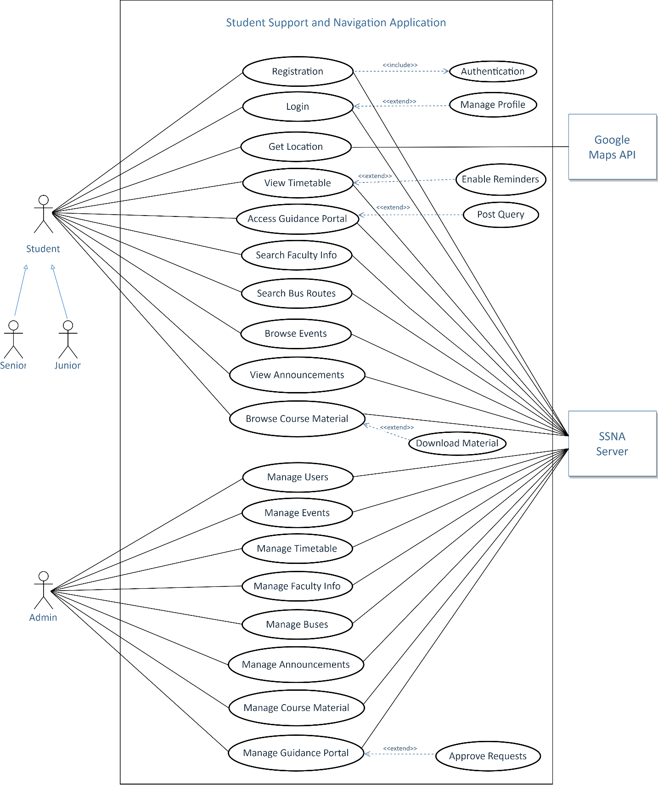

### Figure 1. Use Case Diagram

## **Activity Diagram**

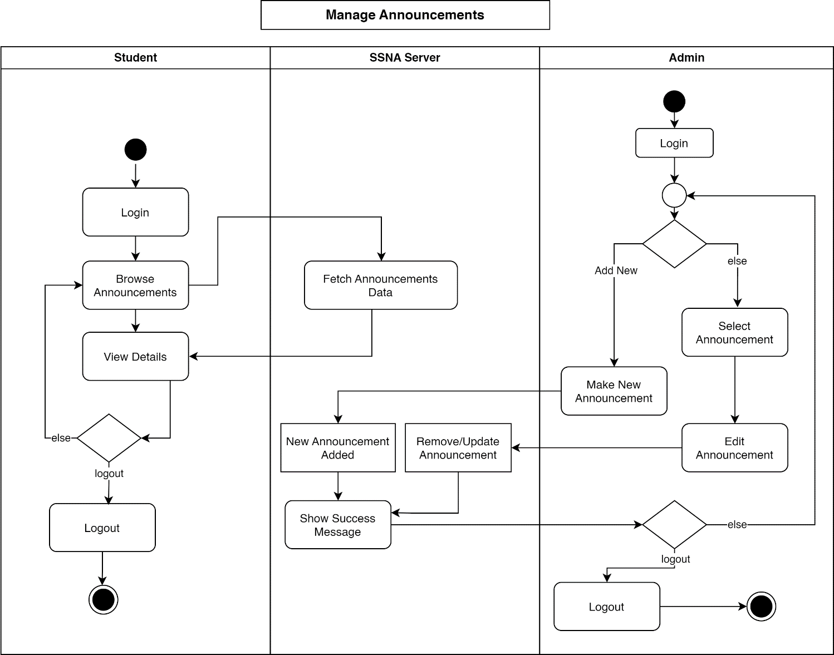

### Figure 2. Activity Diagram 1

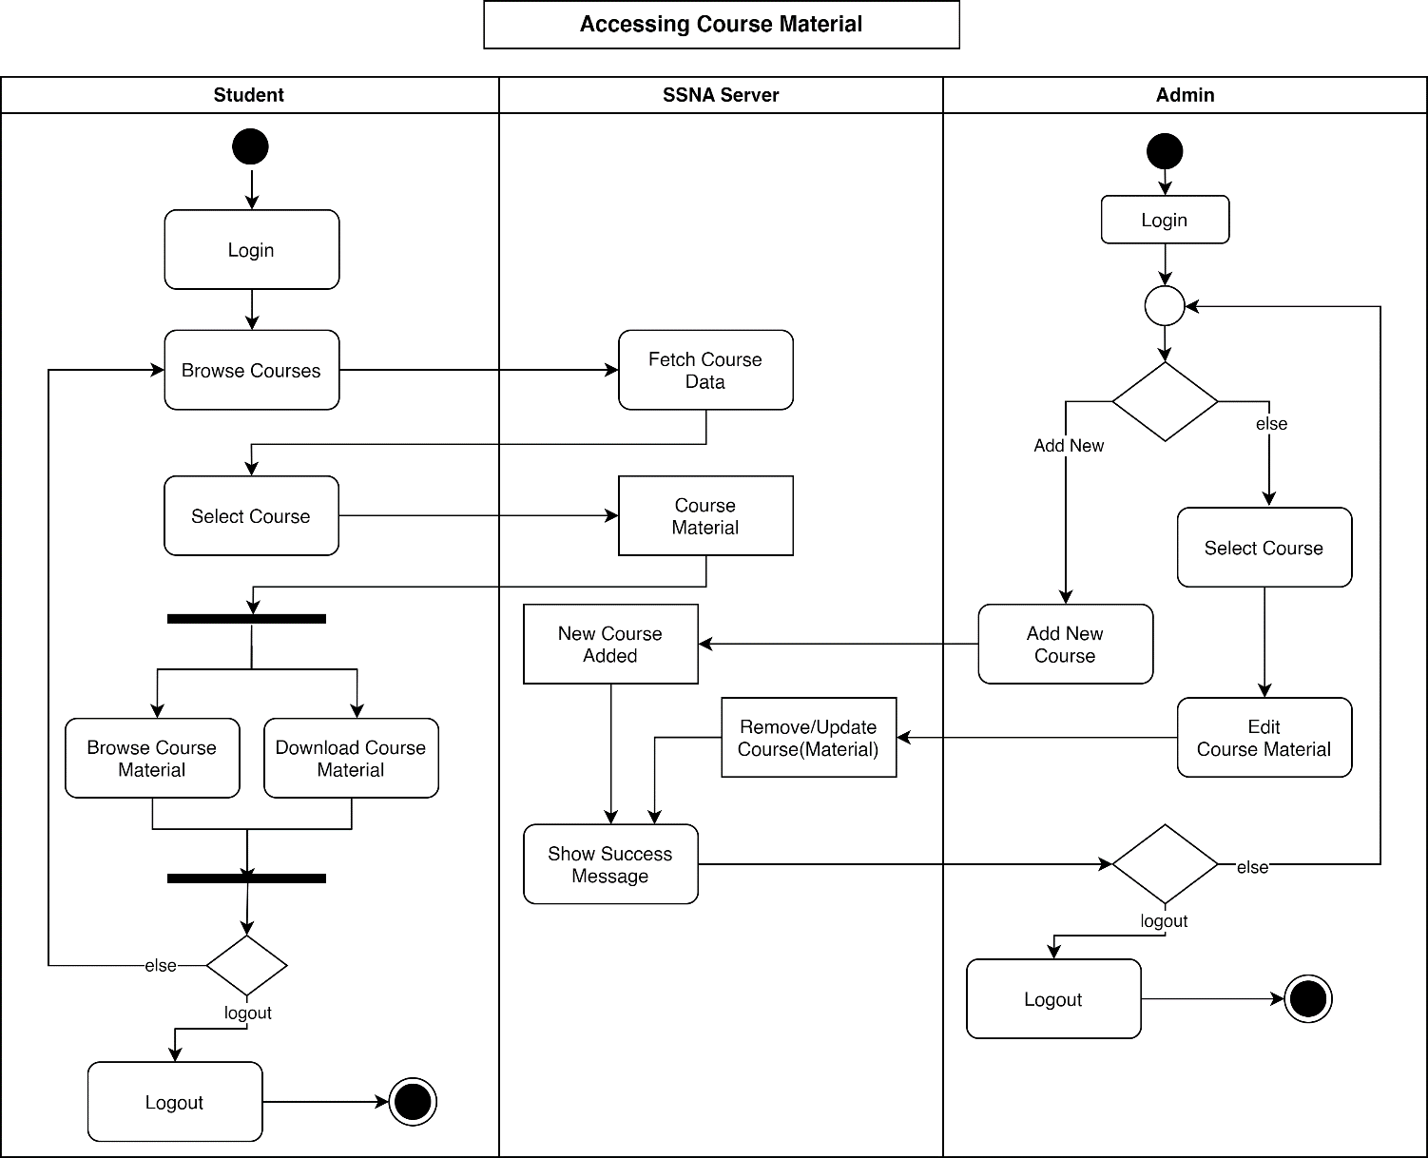

### Figure 3. Activity Diagram 2

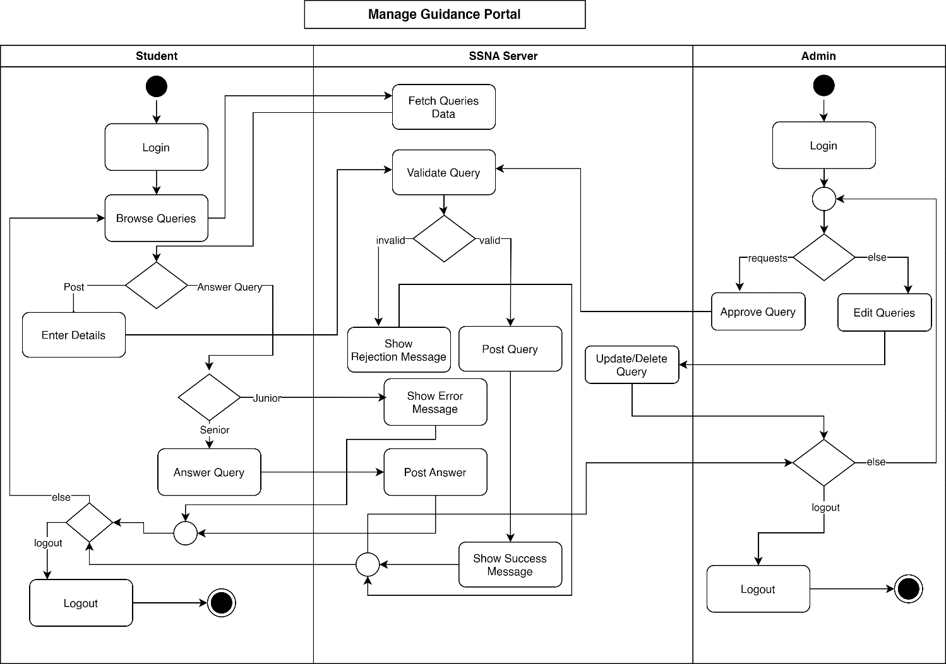

### Figure 4. Activity Diagram 3

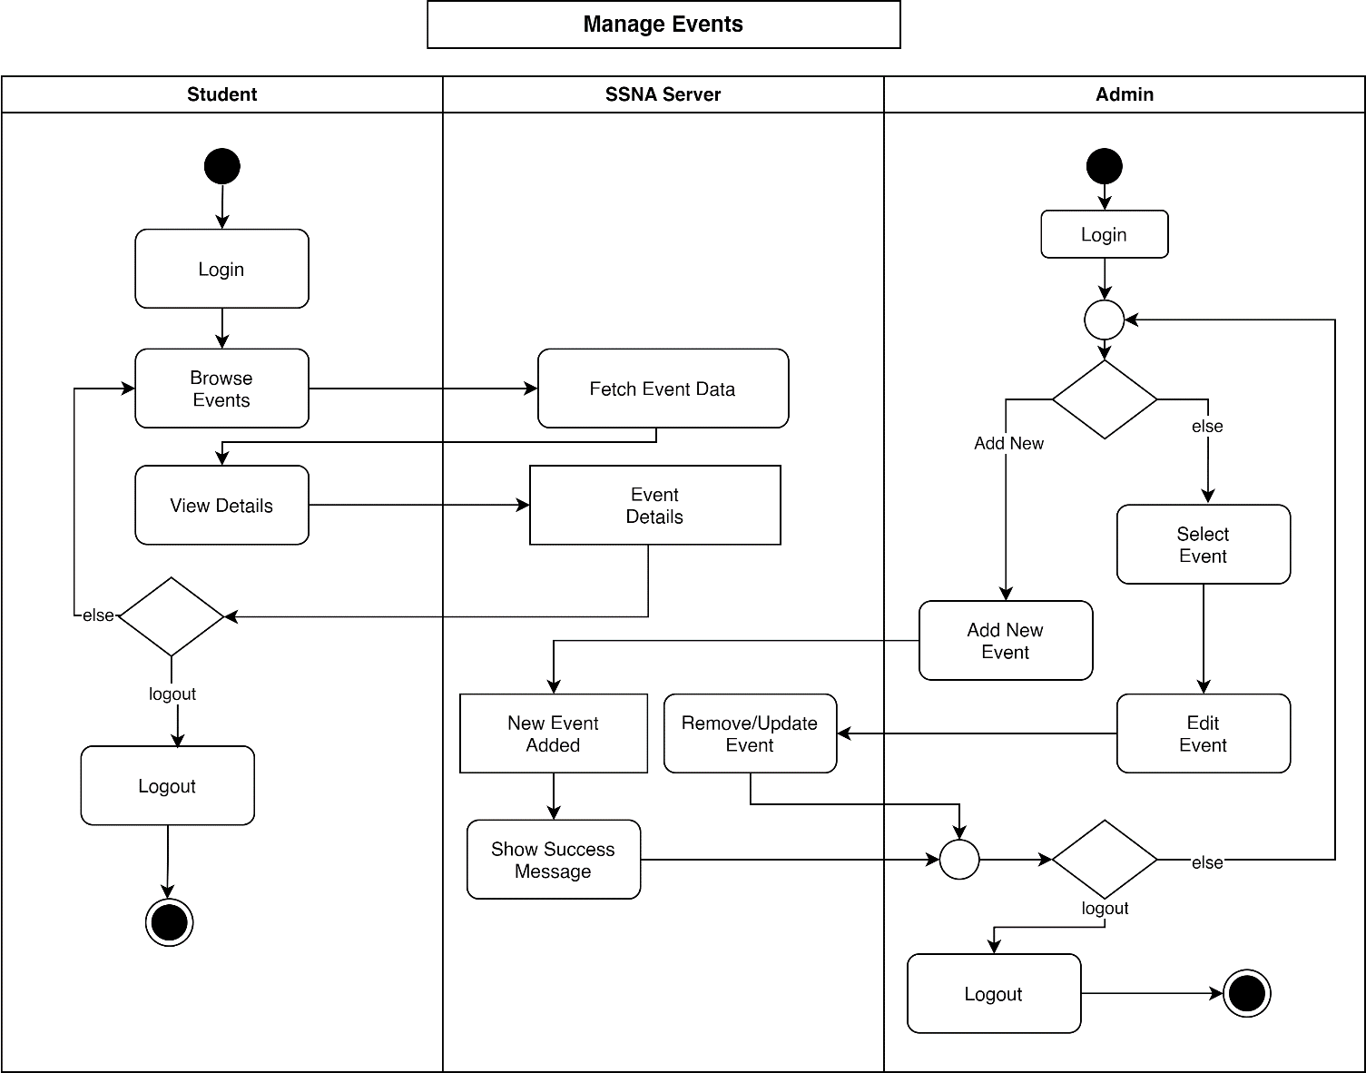

### Figure 5. Activity Diagram 4

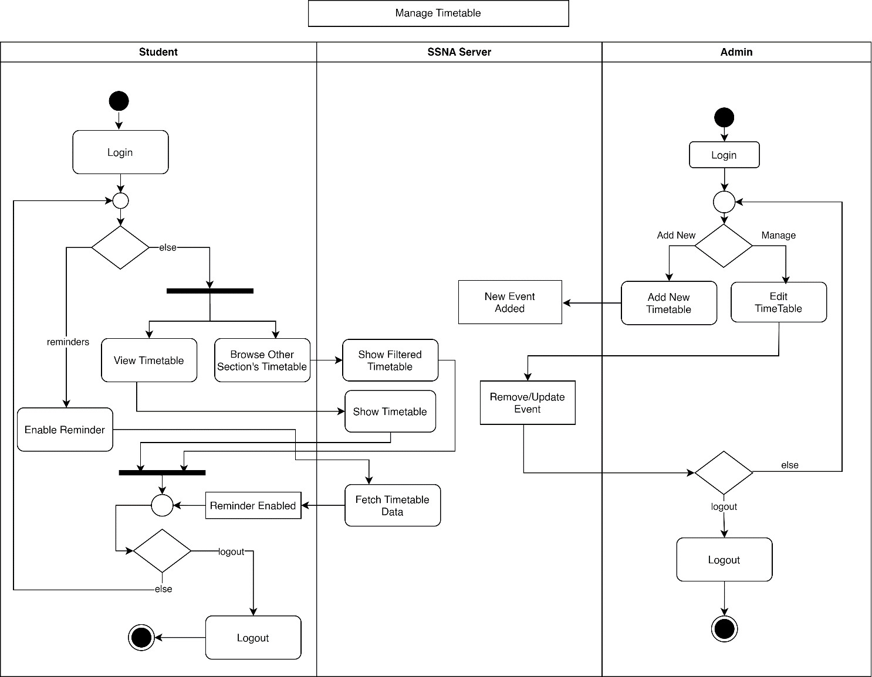

### Figure 6. Activity Diagram 5

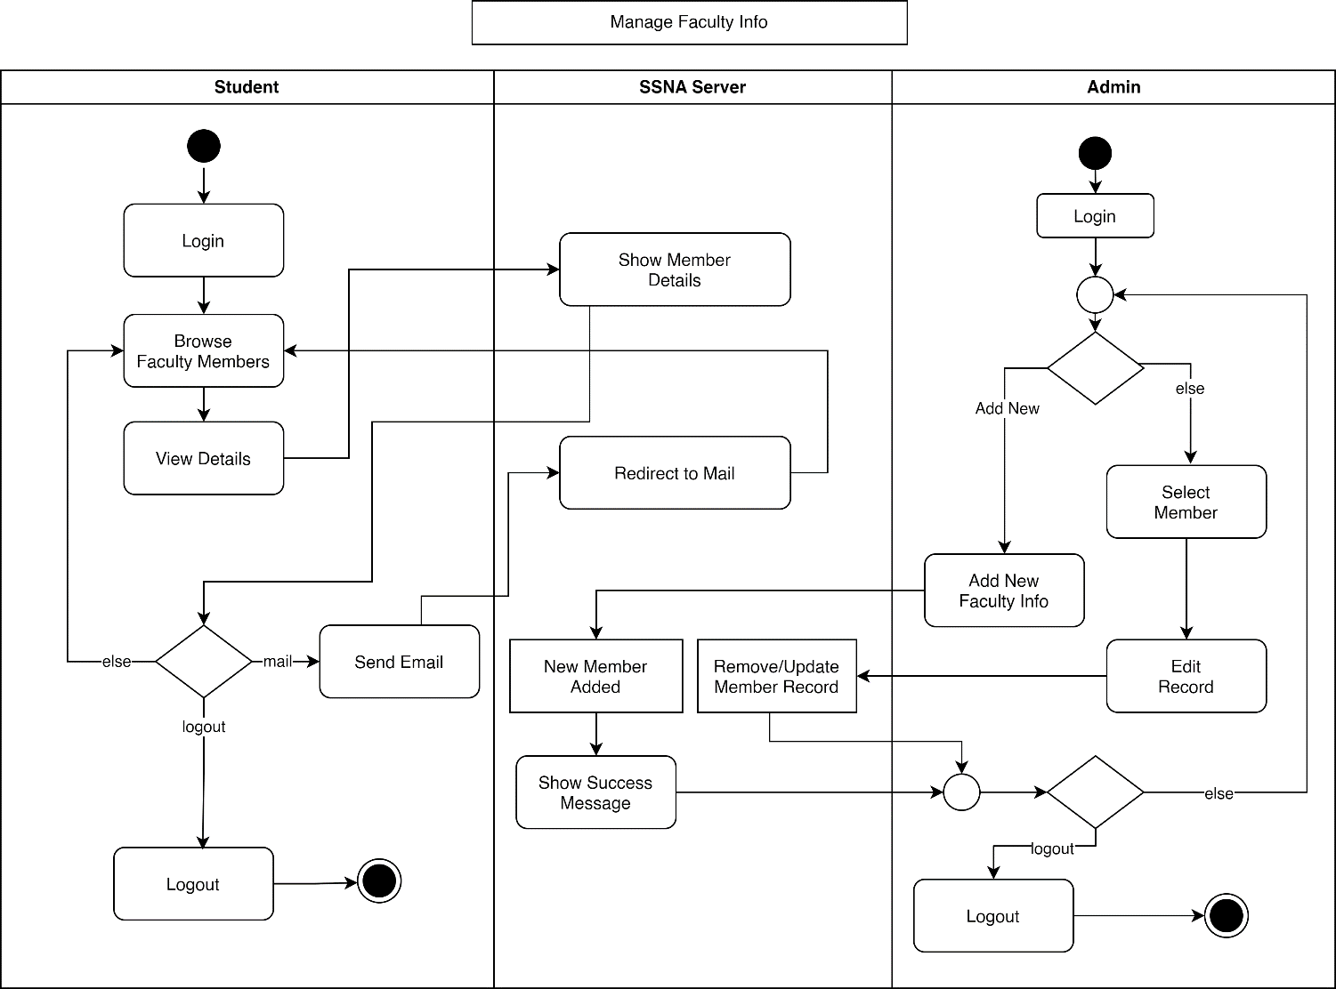

### Figure 7. Activity Diagram 6

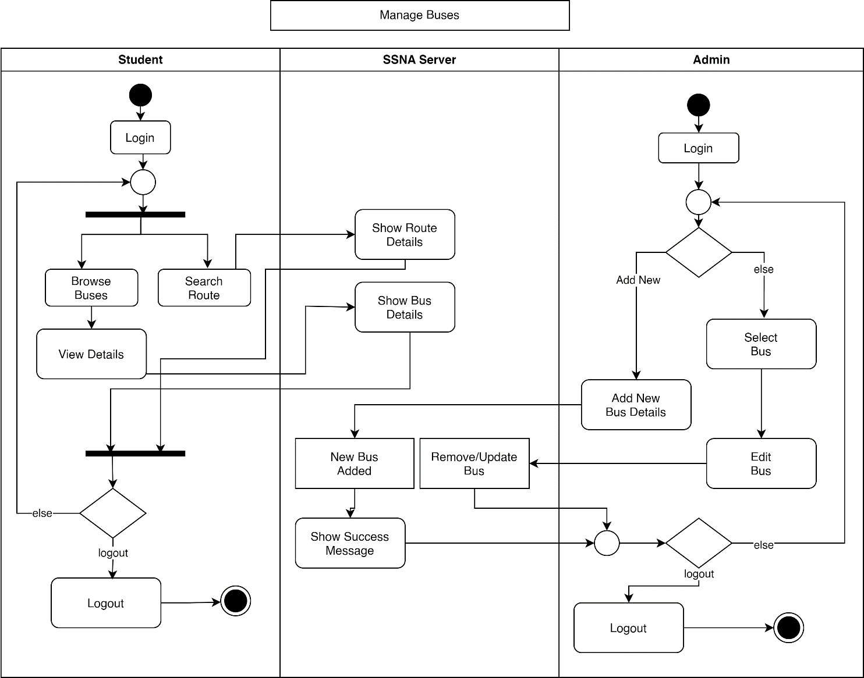

### Figure 8. Activity Diagram 7

## **System Sequence Diagram**

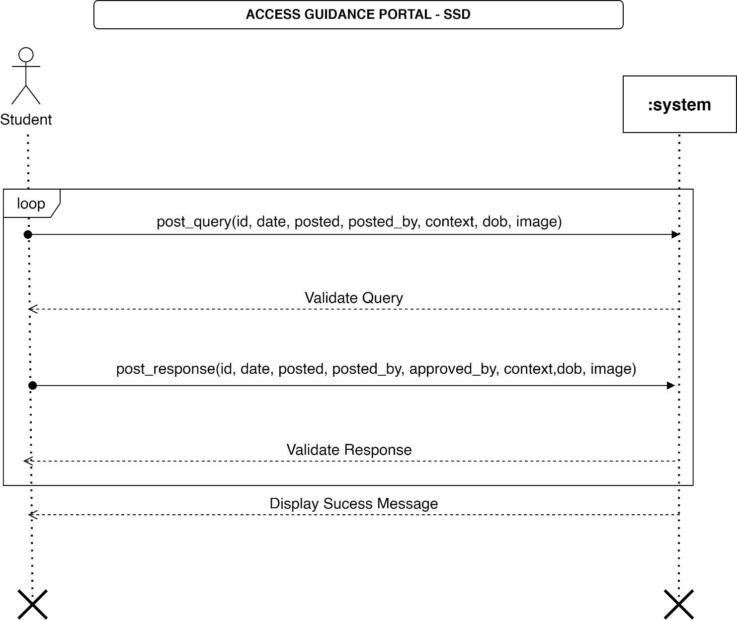

### Figure 9. System Sequence Diagram (SSD)

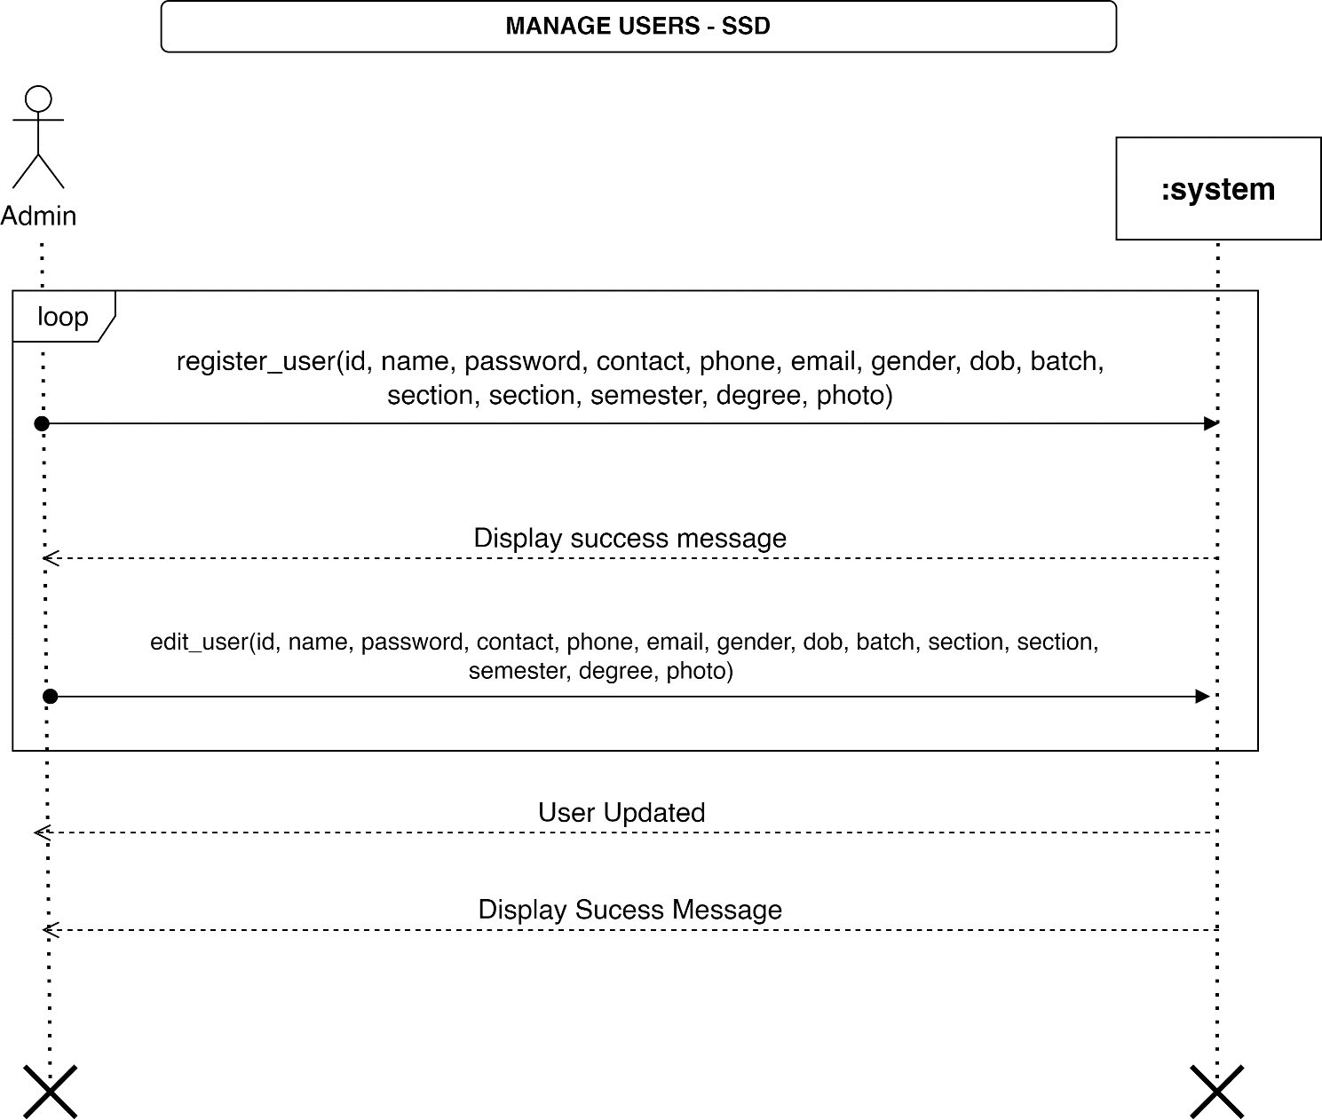

### Figure 10. System Sequence Diagram (SSD)

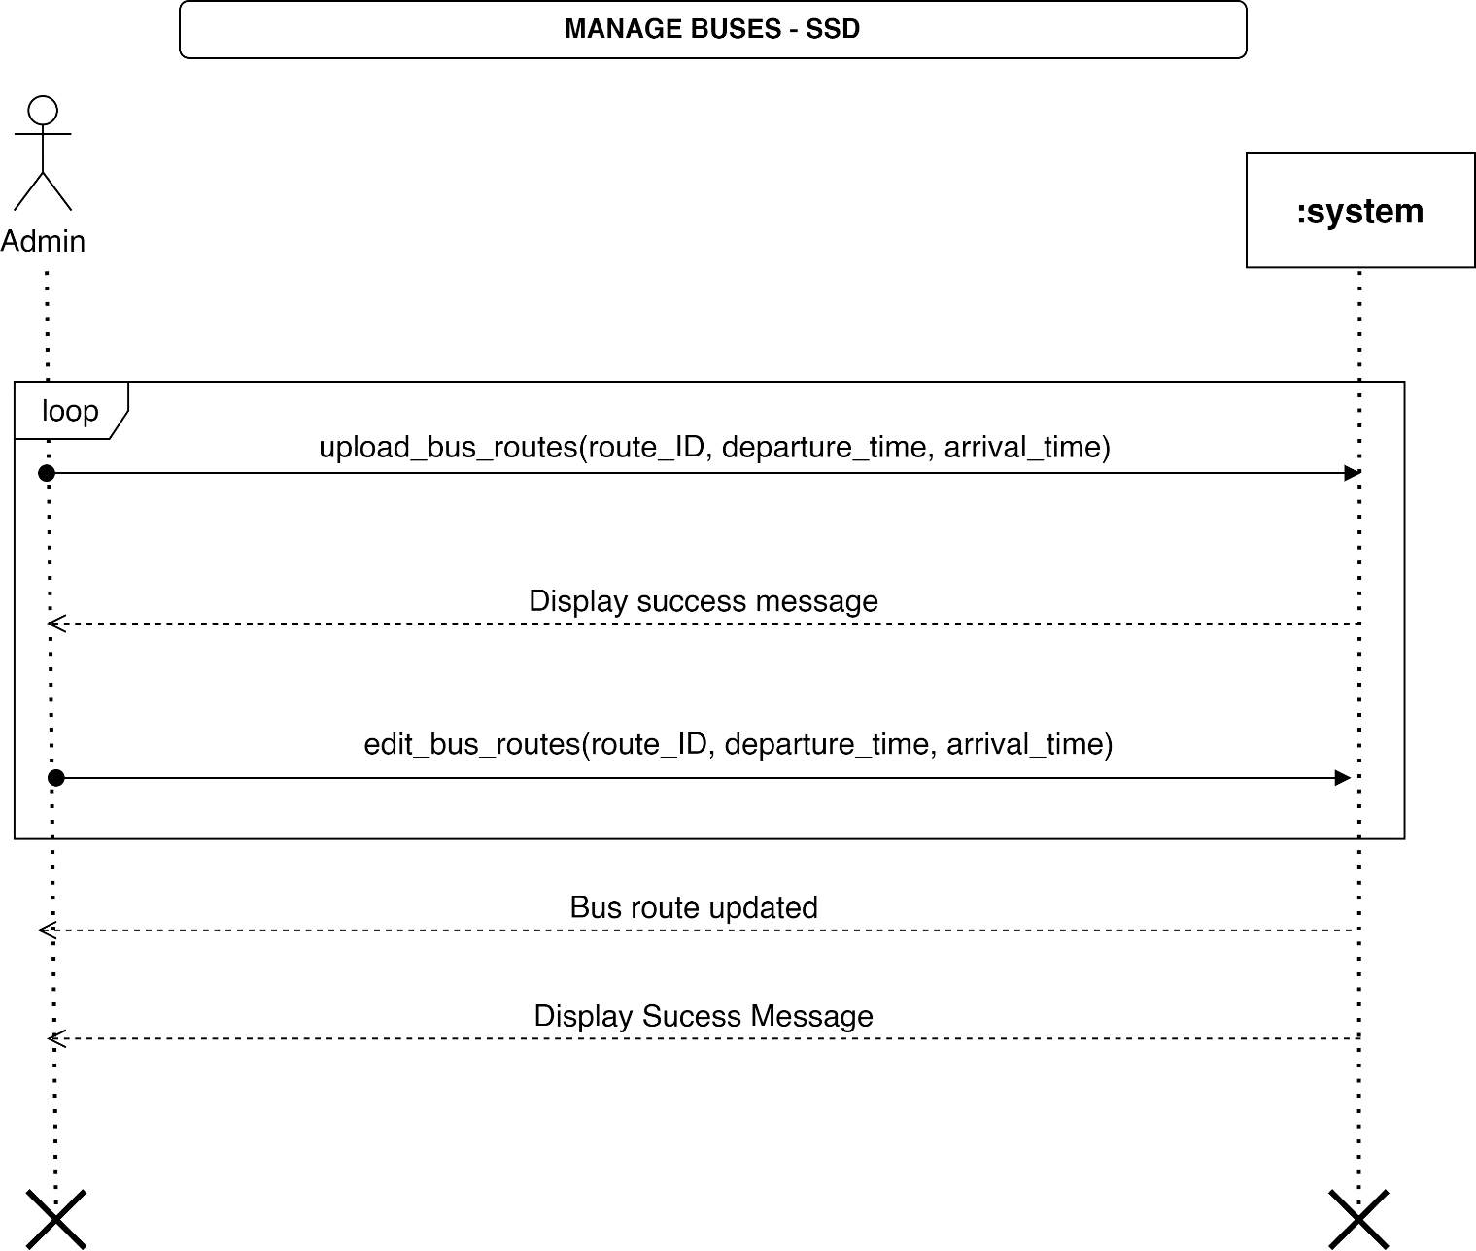

### Figure 11. System Sequence Diagram (SSD)

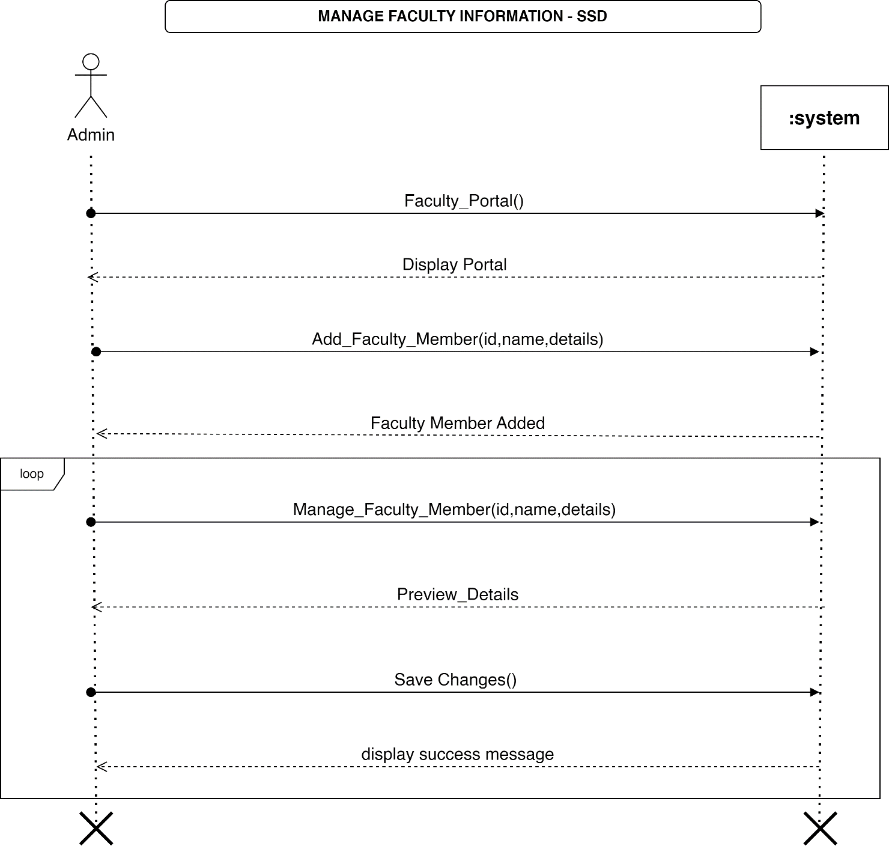

### Figure 12. System Sequence Diagram (SSD)

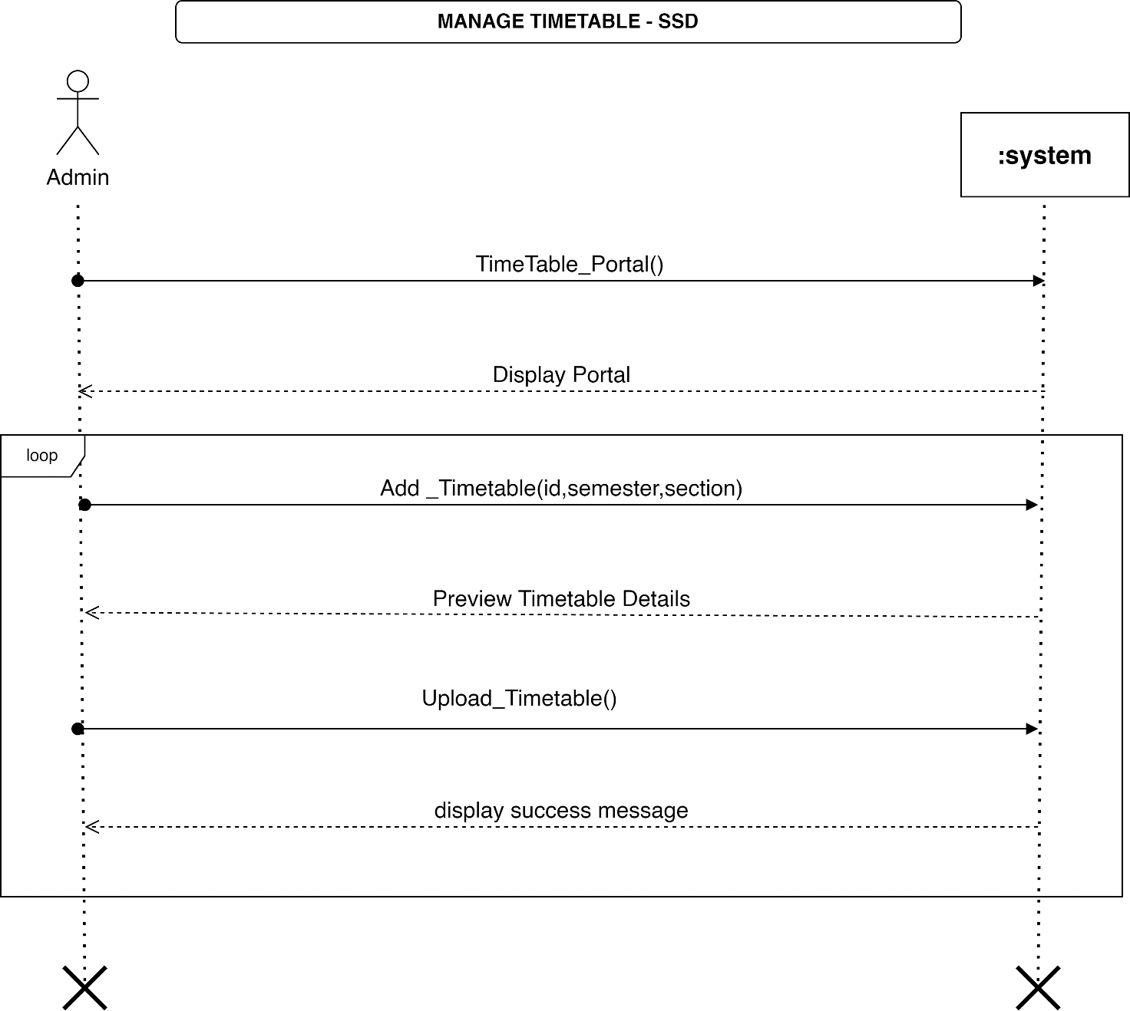

### Figure 13. System Sequence Diagram (SSD)

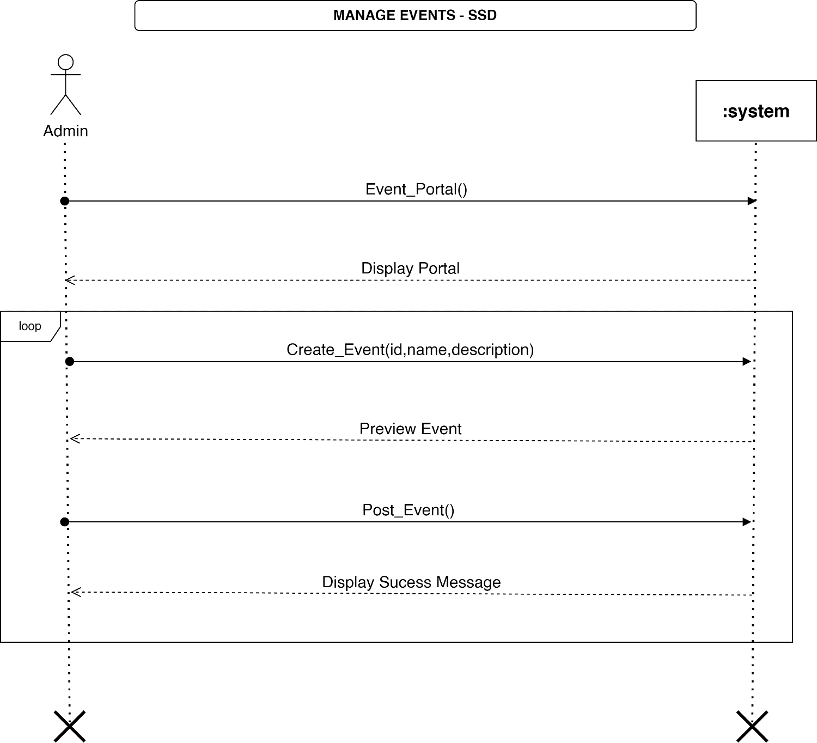

### Figure 14. System Sequence Diagram (SSD)

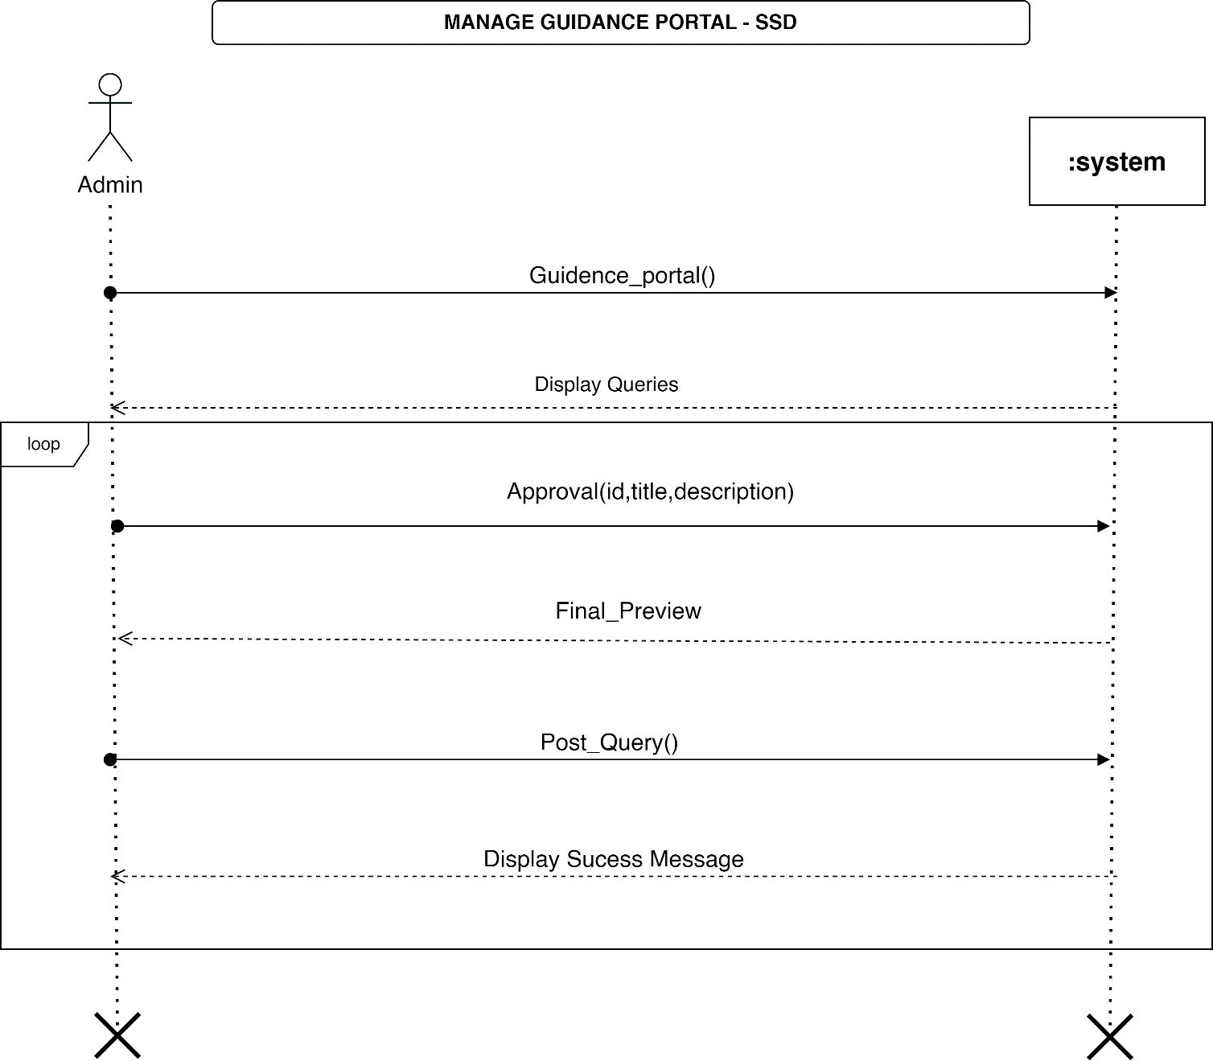

### Figure 15. System Sequence Diagram (SSD) 7

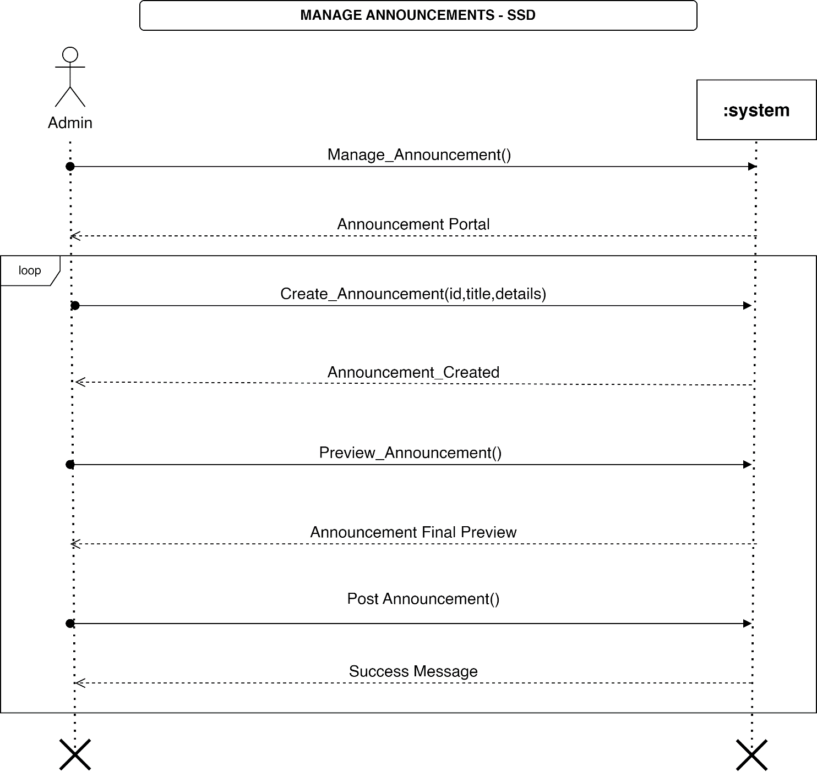

### Figure 16. System Sequence Diagram (SSD) 8

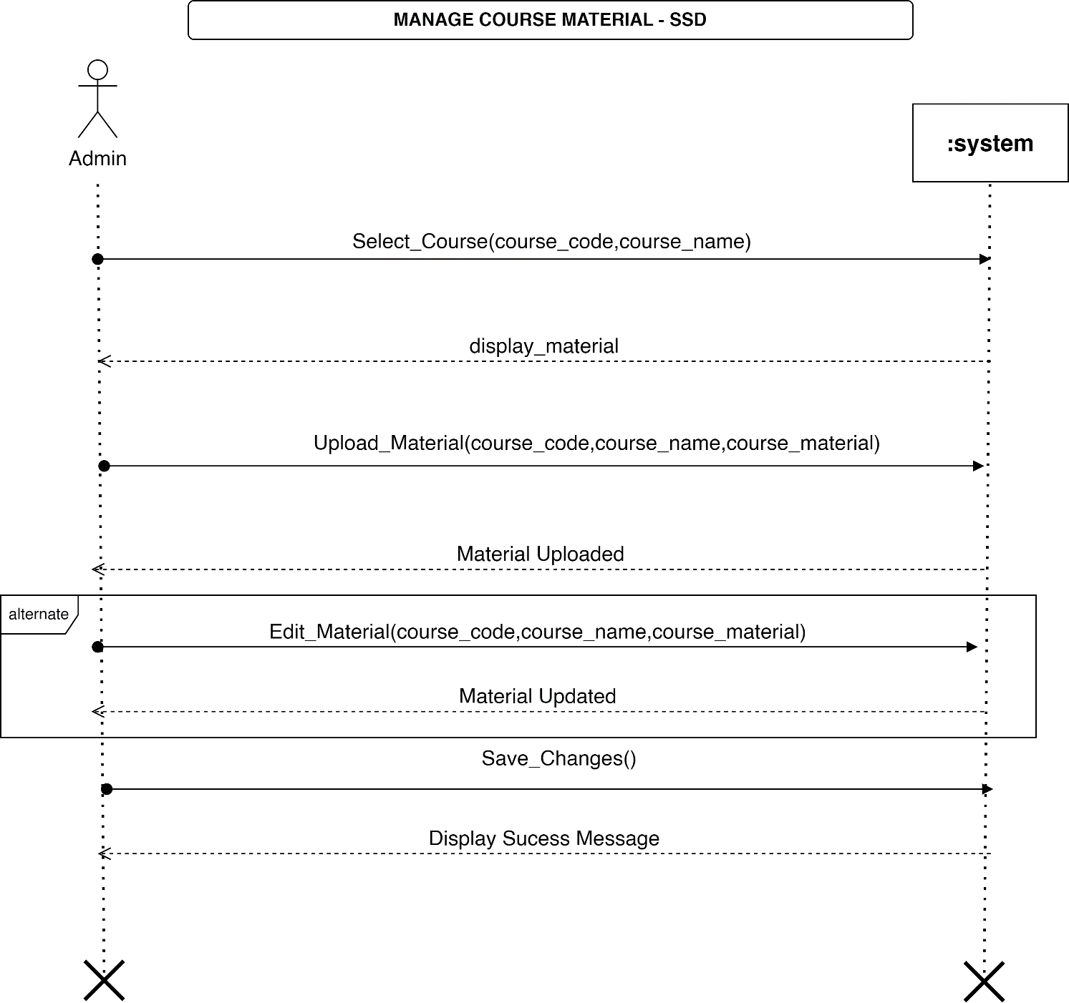

### Figure 17. System Sequence Diagram (SSD) 9

## **Component Diagram**

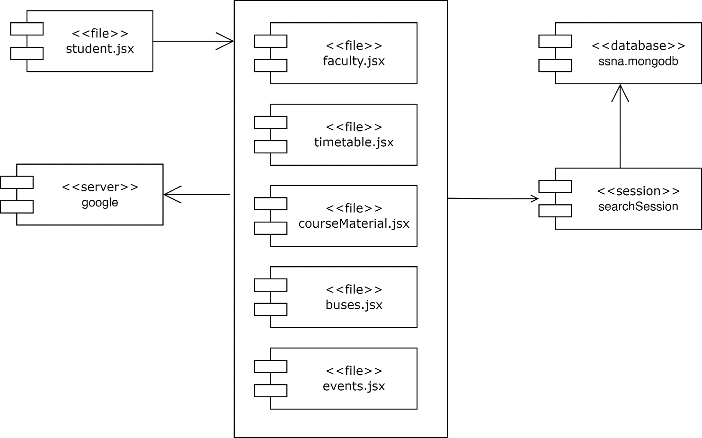

### Figure 18. Component Diagram

## **Data Flow Diagram**

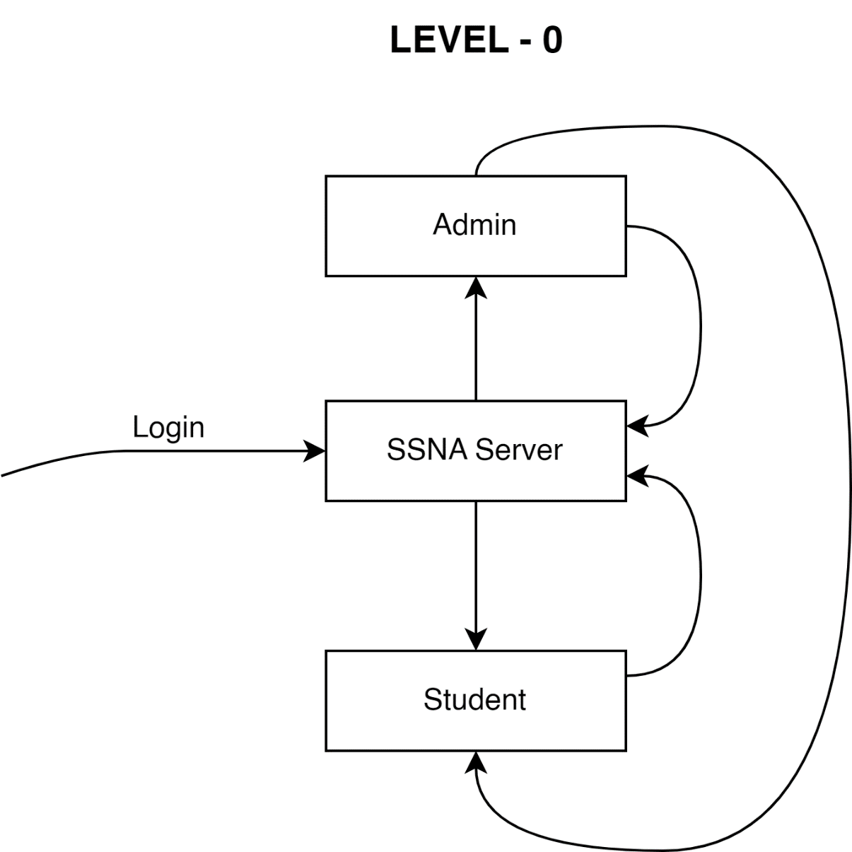

### Figure 19. Data Flow Diagram

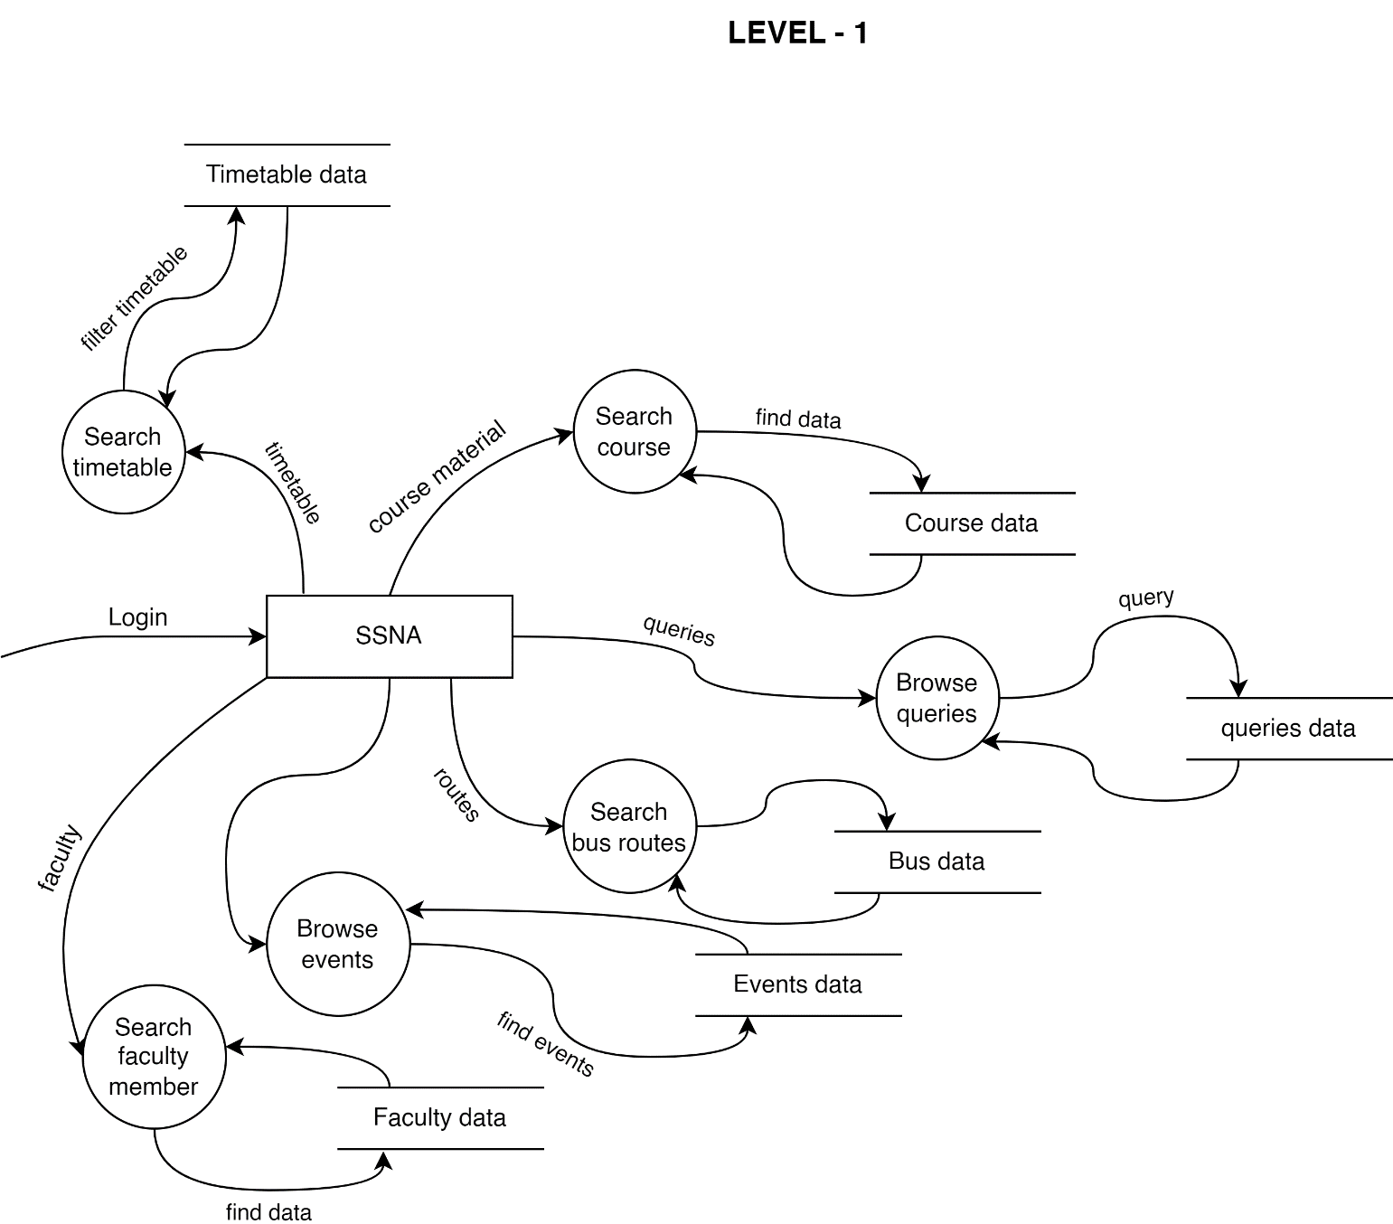

### Figure 20. Data Flow Diagram

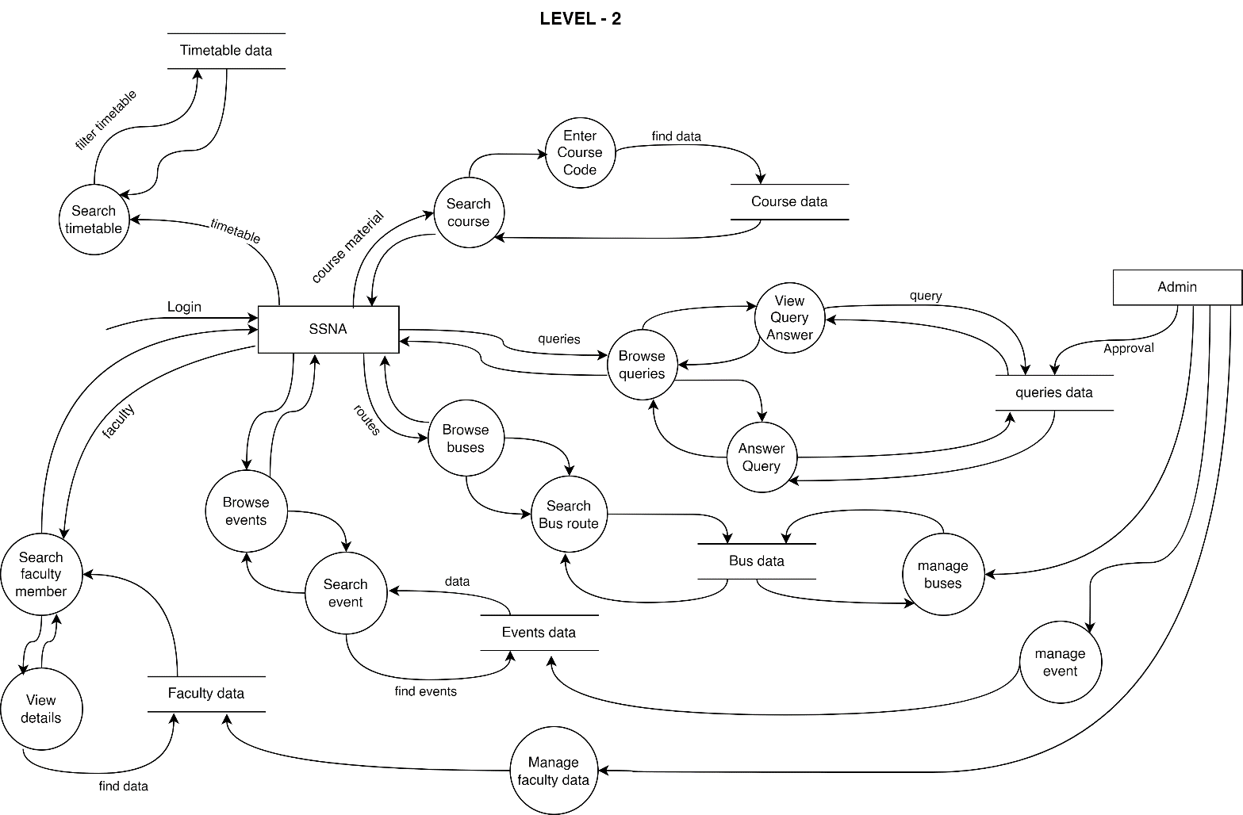

### Figure 21. Data Flow Diagram

## **Database Schema**

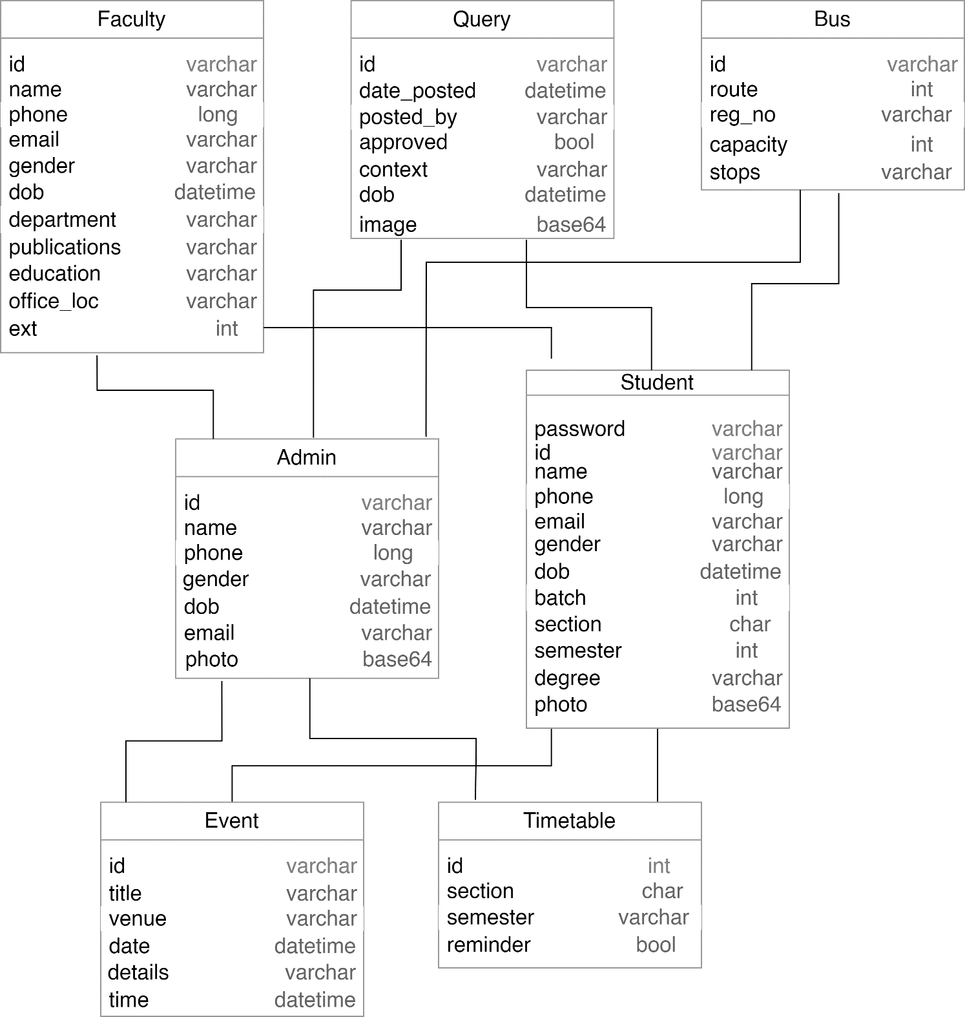

### Figure 22. Database Schema